Image communication project : Random Slotted Aloha with Collision Recovery : second step

Serge Hochar and Mohamed Tahar Nguira

Aim of this step: Find the best transmission scheme for different scenarios of Random slotted Aloha channels with collision recovery given the total number of time slots and the load G. (G = number of sources/number of time slots), for two rate distortion models

-(a+b/(R+c)), (R :Rate)

- , where Rbpp is the rate is bpp = rate(bps)/(FS*S), in our case we consider that a packet contains 1 Mega bits and, S = 400*224 (bits/pixel) , FS =15 frame/second..

All the packets have dimension 1.

During this Step we have considered three Rate-Distortion functions from the first model:

RD1(R) =70+ 50/(R+8)

RD2(R)=50+30/(R+8)

RD3(R)=80+30/(R+10)

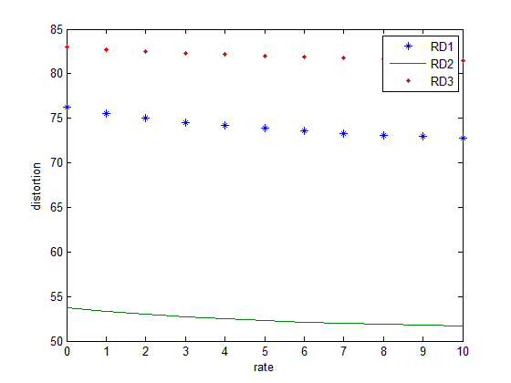

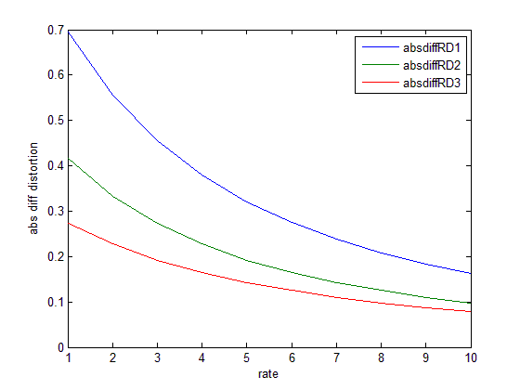

We can see that in general :

$$\left|\frac{∂RD1}{∂R}\right|>\left|\frac{∂RD2}{∂R}\right|>\left|\frac{∂RD3}{∂R}\right|$$

RD3>RD1>RD2

**Model 2**

We have considered also 3 rate distortion functions from the second model :

$RD function1 :100*2^{-\left(2Rbpp\right)}$, $σ1$ ² = 100

$RD function2 :500*2^{-\left(2Rbpp\right)}$, $σ1$ ² = 500

$RD function3 :1000*2^{-\left(2Rbpp\right)}$, $σ1$ ² = 1000

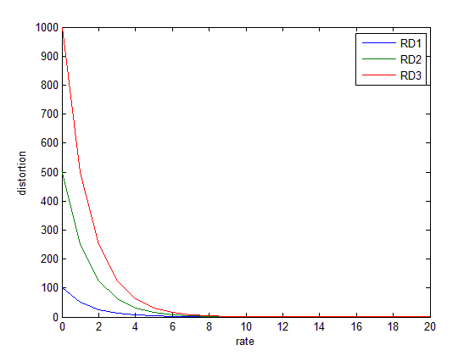

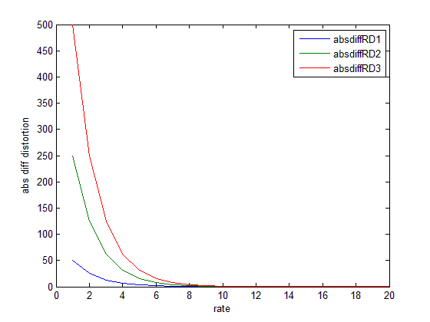

I) Polynomial Degree Distribution Optimization given allocation

This step is divided into 4 Scenarios

**Scenario 1 :**

RD Model 1 :

RD_i are all the same = RD1; we have set Load = 0.7(Load= $\frac{Nb_sources}{nb_time_slots}$), nb_time slots = 40, and we have to minimize the expected distortion for all polynomial distributions.

Inputs : RD = RD1, Load =0.7, nb_time slots = 40=N, the set of vectors over which we want to minimize the distortion is P10(1) : (

with Pi in {0 ,1} and So, the highest possible degree of the polynomials = 9),

Outputs : The set of best degree distribution polynomials

Results : P(x) = $x^{3}$

E(Number of transmissions) = 3

(degree of this polynomial : 3) : We can see that the best degree is 3 . This is due to the fact that if we send more than 3 times, we would exceed the channel capacity and thus the collision recovery algorithm will no longer be able to decode collided packets( channel will be too congested). So 3 times is enough for the RD function considered.

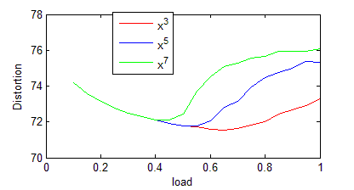

**Model 2**

RD_i are all the same = RD function 1($σ1$ ² = 10000); we have set Load = 0.7(Load= $\frac{Nb_sources}{nb_time_slots}$), nb_time slots = 40, and we have to minimize the expected distortion for all polynomial distributions.

Inputs : RD = RD1, Load =0.7, nb_time slots = 40=N, the set of vectors over which we want to minimize the distortion is P10(1) : (

with Pi in {0 ,1} and So, the highest possible degree of the polynomials = 9),

Outputs : The set of best degree distribution polynomials

Results : P(x) = $x^{2}$

E(Number of transmissions) = 2

(degree of this polynomial : 2) : We can see that the best degree is 2 . This is due to the fact that if we send more than 3 times, we would exceed the channel capacity and thus the collision recovery algorithm will no longer be able to decode collided packets( channel will be too congested). So 2 times is enough for the RD function considered. And since this RD function decreases too fast, it behaves like a constant for large R and thus 2 times transmission is enough for each packet in order to minimize the expected distortion.

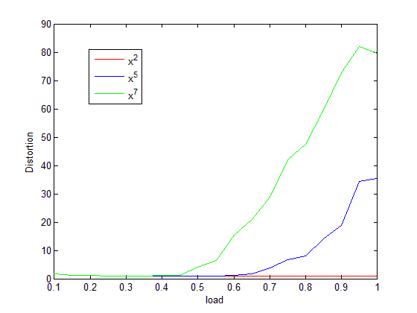

Scenario 2 : Minimize the expected distortion over all possible distribution probabilities P1 and P2 in the set P10(1).

**RD Model 1 :**

Inputs : Two RD functions : $σ1$ ² = 10000, $σ2$ ² = 50000 (two classes) , load =0.7,nb_time slots =40 , set of polynomials: P10(1),( ( $\left\{\sum_{i=1}^{10}{P_{i}}x^{i-1}\right\}$ with Pi in {0, 1} and $\left\{\sum_{i=1}^{10}{P_{i}}=1\right\}$) number of sources from class 1: L1= 14, number of sources from class 2 : L2= 14.

Output : P1 and P2

P1(x) = $x^{5}$:Expected number of transmissions :5

P2(x) = $x^{2}$: Expected number of transmissions : 2

We can see that the transmission scheme of class 1 is more aggressive than the class 2's transmission scheme. This can be explained by the fact that $\left|\frac{∂RD1}{∂R}\right|>\left|\frac{∂RD2}{∂R}\right|$ and thus, in order to minimize distortion, it's more profitable to increase class one's rate rather than class 2's rate.

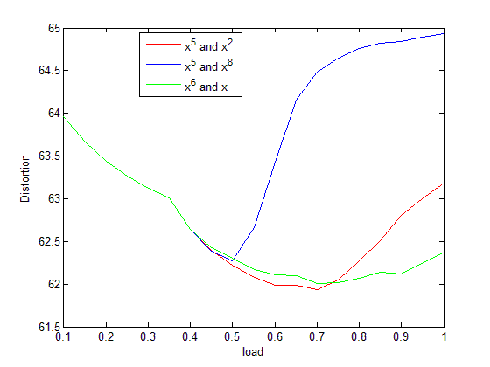

**RD Model 2 :**

Inputs : Two RD functions : RD1, RD2 (two classes) , load =0.7,nb_time slots =40 , set of polynomials: P10(1),( ( $\left\{\sum_{i=1}^{10}{P_{i}}x^{i-1}\right\}$ with Pi in {0, 1} and $\left\{\sum_{i=1}^{10}{P_{i}}=1\right\}$) number of sources from class 1: L1= 14, number of sources from class 2 : L2= 14.

Output : P1 and P2

P1(x) = x :Expected number of transmissions :1

P2(x) = $x^{5}$: Expected number of transmissions : 5

We can see that the transmission scheme of class 1 is more aggressive than the class 2's transmission scheme. This can be explained by the fact that $\left|\frac{∂RD2}{∂R}\right|>\left|\frac{∂RD1}{∂R}\right|$ and thus, in order to minimize distortion, it's more profitable to increase class one's rate rather than class 2's rate.

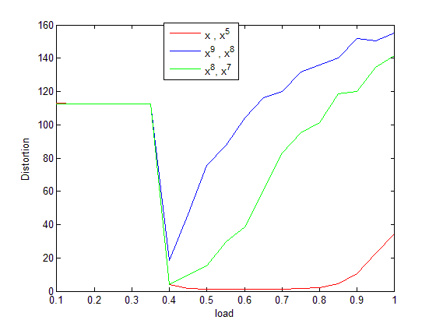

Scenario 3:

**RD Model 1 :**

Same as scenario 2 but L1 = 20(number of second class sources = 0.7*40-20 =8)(Load= 0.7)

P1(x)= $x^{2}$: Expected number of transmissions : 2

P2(x) = $x^{7}$: Expected number of transmissions : 7

Since we have more packets in class 1 than class2, thus, class1 will have a higher source allocation than class2, thus in order to minimize the expected distortion (Dis1+Dis2)/2, we need to increase the aggressiveness of class2's transmission's scheme(Expected number of TX for each packet) and since L1 is much higher than L2, the system prefers to inverse its priorities by decreasing the expected number of transmissions of class1's packets and increasing the expected number of class2's transmissions.

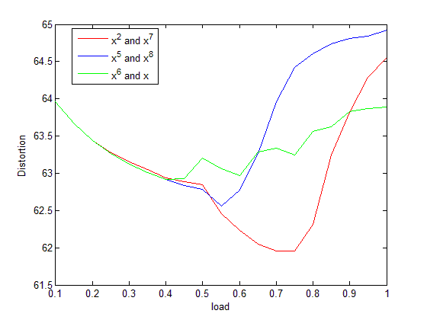

**RD Model 2 :**

Same as scenario 2 but L1 = 5)number of second class sources = 0.7*40-5 =23)(Load= 0.7)

P1(x)= $x^{9}$: Expected number of transmissions : 9

P2(x) =x : Expected number of transmissions : 1

Since we have more packets in class 2 than class1, thus, class2 will have a higher source allocation than class1, thus in order to minimize the expected distortion (Dis1+Dis2)/2, we need to increase the aggressiveness of class1's transmission's scheme(Expected number of TX for each packet) and since L2 is much higher than L1, the system prefers to inverse its priorities by decreasing the expected number of transmissions of class2's packets and increasing the expected number of class1's transmissions.

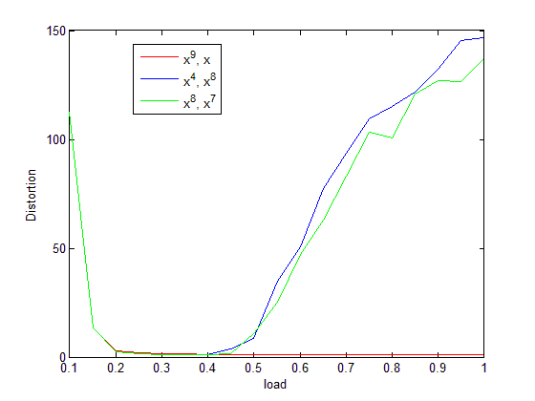

Scenario 4 :

Minimize the expected distortion over all possible distribution probabilities P1, P2 and P3 in the set P10(1).

**RD Model 1:**

Inputs : Three RD functions : RD1, RD2, RD3 (3 classes) , load =0.7,nb_time slots =40, set of vectors : P10(1) number of sources from class 1: L1= 5, number of sources from class 2 : L2=9 and number of sources from class 3 : 14.

Output : P1, P2, P3

P1(x) = $x^{9}$:Expected number of transmissions : 9

P2(x) = $x^{3}$:Expected number of transmissions : 3

P3(x) = $x^{2}$: Expected number of transmissions : 2

Since we have this inequality : $\left|\frac{∂RD1}{∂R}\right|>\left|\frac{∂RD2}{∂R}\right|>\left|\frac{∂RD3}{∂R}\right|$, we know that in order to minimize the distortion , we have to transmit Class1's packets more times than Class2's packets and the smallest number of transmissions should be affected to class3's packets since it has the smallest effect on the RD function. And this process is accentuated by the fact that class1 has the smallest number of Trials( L1 = 5) thus , it's scheme is more aggressive than class2 (L2 = 5). And class 3 has the highest source allocation and thus it needs less aggressiveness. (expected number of transmissions for each packet = 2) in order to let the others minimize their distortion.

(We can minimize distortion by increasing source allocation or by optimizing the degree distributions)

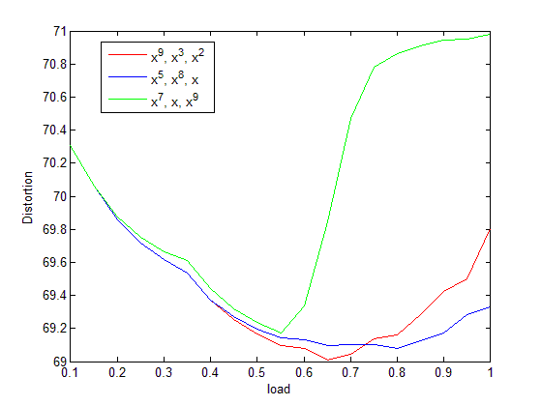

II)Polynomial Degree Distribution and Source Allocation Optimization

Scenario : Minimize the expected distortion over all possible distribution probabilities P1 and P2 in the set P10(1), over all possible combinations of L1 and L2, such that L1+L2 = nb_time slots*load. (L1 packets RD1 and L2 packets RD2)

**RD Model 1:**

Inputs : Two RD functions : RD1, RD2 (two classes) , load =0.7,nb_time slots =20 , set of polynomials : P10(1),( ( $\left\{\sum_{i=1}^{10}{P_{i}}x^{i-1}\right\}$ with Pi in {0, 1} and $\left\{\sum_{i=1}^{10}{P_{i}}=1\right\}$)

Output : P1 , P2, L1 and L2

P1(x) = $x^{4}$:Expected number of transmissions : 4

P2(x) =x: Expected number of transmissions : 1

L1 = 10 , L2 = 4

For this optimization problem we get L1= 10 and L2 =4. We can see that since RD1 has a higher absolute derivative than RD2, thus, its scheme is more aggressive than for RD2. In order to minimize distortion, the channel prefers to allocate more source allocation to L1 in order to minimize distortion because it permits to reinforce the effect of the polynomial degree distribution and thus minimize Distortion.(There is more gain with RD1 than RD2)

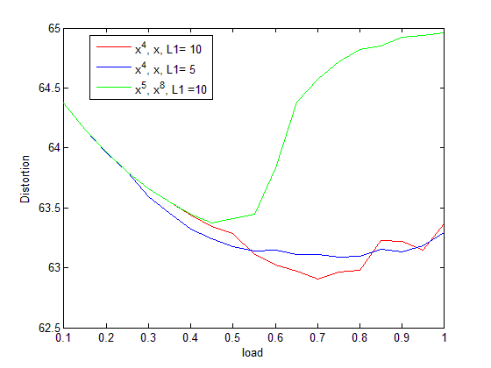

**RD Model 2:**

Inputs : Two RD functions : RD1, RD2 (two classes) , load =0.7,nb_time slots =20 , set of polynomials : P10(1),( ( $\left\{\sum_{i=1}^{10}{P_{i}}x^{i-1}\right\}$ with Pi in {0, 1} and $\left\{\sum_{i=1}^{10}{P_{i}}=1\right\}$)

Output : P1 , P2, L1 and L2

P1(x) = $x$:Expected number of transmissions : 1

P2(x) = $x^{6}$: Expected number of transmissions : 6

L1 = 9 , L2 = 5

For this optimization problem we get L1= 9 and L2 =5. We can see that since RD2 has a higher absolute derivative than RD1, thus, its scheme is more aggressive than for RD1 In order to find the equilibrium between the source allocation and the polynomial degree distribution, if the polynomial has a low degree, it has a higher allocation. That's why L1>L2.

